eHealthNB Centre, Powered by iTacit
Self-registration
If you do not currently have a login for our learning platform, the instructions below will assist you in the self registration process. Refer to screenshot below.
- Access eHealth NB Centre by clicking on this link: https://ehealthnbcentre.itacit.com.
- If you need to change your language, select the drop down to the top right. Self-Registering with your preferred language will ensure that communications will be in the language of your choice.
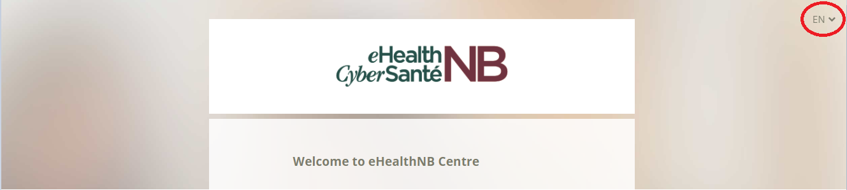

- Select “Get Started” and complete the fields as prompted (refer to screenshot below):

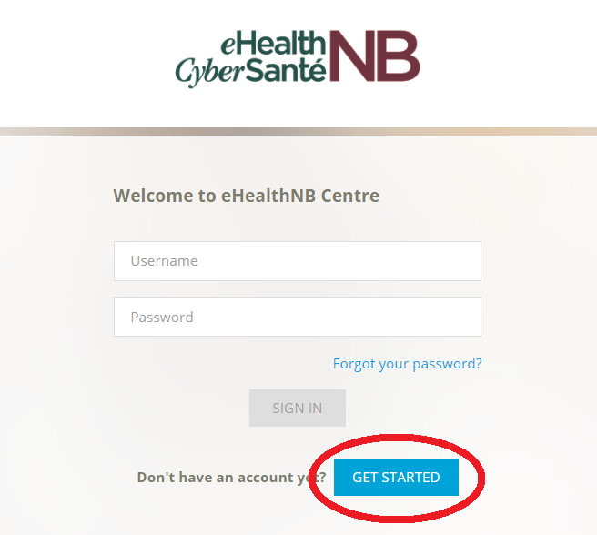

- Enter the email address to which you want to receive communications and training.

- Select “EHR – Electronic Health Record” as your location along with the role that best describes your position (refer to screenshot below):

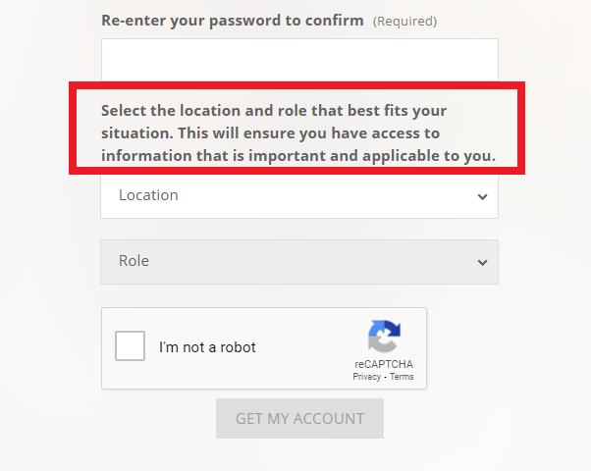

- Choosing your role (refer to screenshot below):
  - Where applicable, roles a re combined to include both clinical (if you are a licensed professional) and non-clinical options (If you do not have a licensing body).
  - Electronic Medical Record (EMR) is a software solution provided by a certified EMR vendor that allows for electronic patient charting. If your medical office uses this type of software solution, choose Electronic Medical Record Office.
  - Private sector refers to both clinical and support staff not employed by the provincial government, Regional Health Authorities (RHAs) or by an EMR.
  - Federal government refers to individuals employed at federal institutions, such as First Nations, Corrections and Department of National Defence.
  - GNB Staff refers to individuals employed at Government of New Brunswick.

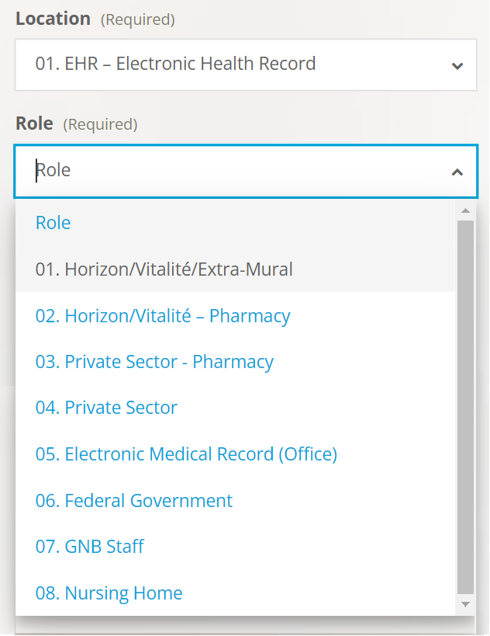

- When you have filled out the required information, click “Get My Account”.
- After this step, you will be sent a validation email. Please click on the link contained in the email to validate your account.
- Once your email is validated, you will be able to login to the eHealthNB Centre.

